Mechanical weed control in organic fruit growing: Thread mowers
Applicability box
Theme
Crop production, Horticulture, Temperate fruits
Keywords
Weed control, cultivation measures, yield stability
Context
Central Europe
Application time
Spring-Autumn
Equipment
Tractor, Thread mower
Best in
Organic orchards

Problem
Weed control in the tree strip is very important in organic fruit production. However, herbicides are not allowed and many mechanical cultivation tools are difficult to use in wet soil conditions.

Solution
The thread mower regulates the weeds in the tree strip by mowing the above-ground vegetation without breaking up the soil and thus can be implemented, regardless of the weather conditions.

Benefits
Large weeds are also removed from the entire tree strip. The soil-conserving tillage prevents erosion and nitrogen release.

Practical recommendations

- Vertically rotating plastic filaments (PU) cut the above-ground plant parts in the tree strip.
- Different thread thicknesses and shapes are available. Use the advice of your agricultural advisor to select the best choice for your farm.
- The threads wear out through use and must be retightened manually. Abrasion is highly dependent on the soil type, soil wetness, and the "sharpness" of the treatment. Avoid using the thread mower in very dry soil conditions to minimize thread wear.
- If you work in a combination strategy with other devices, use the thread mower mainly in summer (approx. from July).
- In young plants, the weed pressure on good soils is usually too high for the sole use of the thread mower device to be sufficient (water/nutrient competition). Older plants (>7th standing year) might also be treated with the thread mower all year round if necessary, this is dependent on varieties present in the orchard, soil type, weed pressure, etc.

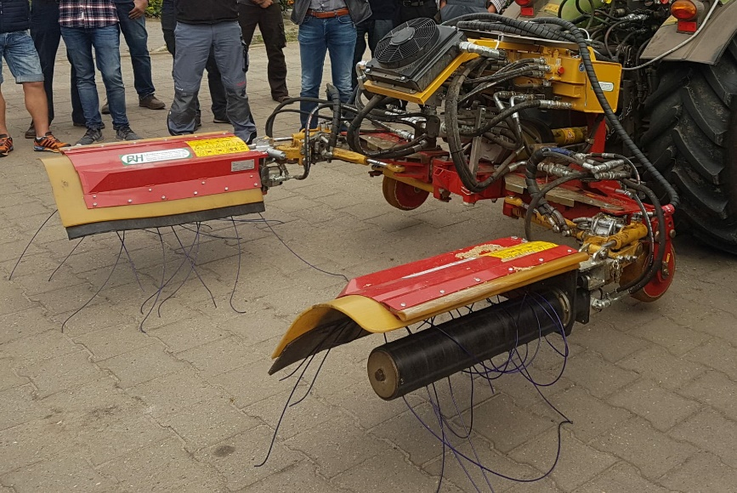  Picture 1. Thread mower by SEPPI, Photo: N. Oeser, FÖKO, 2018. | Picture 2. Thread mower by LADURNER in action, Photo: N. Oeser, FÖKO, 2018.

Further reading
  - Video
- Thread mower, guide to weed control in apple growing, Agroscope.
  - Weblinks
- Oeser, N. 2018. Presentation of mechanical soil cultivation equipment for weed control in trees (Öko-Obstbau Magazine, German)
- Mora Vargas, A., Kelderer, M. 2023. Practice Abstract How to control weeds in organic pome fruit. Laimburg. BIOFRUITNET.
- Oeser, N. 2023. Practice Abstract Mechanical weed control in organic orchards: Gyroscopic crumblers. FÖKO. BIOFRUITNET.
- Lindhard Pedersen, H. 2023. Practice abstract Advantages and disadvantages of weed control in tree rows using soil coverage. Hortiadvice. BIOFRUITNET.
- Oeser, N. 2023. Practice Abstract Weed control in Organic pome fruit growing: Combined strategy of different approaches. FÖKO. BIOFRUITNET.
- Oeser, N. 2023. Practice Abstract Mechanical weed control in organic orchards: Roll hoes. FÖKO. BIOFRUITNET.
- Check the Organic Farm Knowledge platform for more practical recommendations.

About this practice abstract
Publisher: Fördergemeinschaft Ökologischer Obstbau e.V. (FÖKO)
Traubenplatz 5, D-74189 Weinsberg
foeko@foeko.de, www.foeko.de
Author: Niklas Oeser (FÖKO)
Contact: niklas.oeser@esteburg.de

Review: Ilsa Phillips (IFOAM Organics Europe), Lauren Dietemann (FiBL)
Permalink: Organic-farmknowledge.org/tool/45988
Project name: BIOFRUITNET- Boosting Innovation in ORGANIC FRUIT production through stronger networks
Project website: https://biofruitnet.eu
© 2023

